

**Scale – Maps**

**Scale – 1cm :**

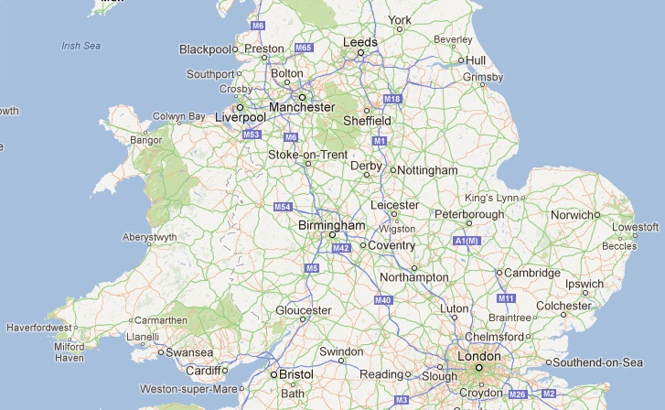

**Measure the distances on the map from one location to another. Be as accurate as you can.**

|  |  |  |
| --- | --- | --- |
| **x to y** | **Distance on the map** | **Actual distance in real life** |
| Liverpool to Manchester |  |  |
| Bolton to Blackpool |  |  |
| Leeds to London |  |  |
| York to London |  |  |
| Aberystwyth to Cardiff |  |  |
| Birmingham to Coventry |  |  |
| Bath to Leicester |  |  |
| Liverpool to Hull |  |  |
| Cambridge to Swansea |  |  |